Ex. No. 1 | Design A Website Using HTML5
Date of Exercise
GitHub Host Link

Aim

To design and develop a simple yet structured HTML5-based website using various essential HTML5 tags
and features that demonstrate a clear understanding of semantic elements and formatting techniques.

Description

This exercise involves creating a simple HTML5 website named 'StarVerse'. The website consists of two
web pages: Home and Today's Horoscope. It demonstrates the use of HTML5 semantic elements, headings,
paragraphs, hyperlinks, tables, lists, CSS styling, and navigation links. The website follows proper
formatting and uses suitable background and text colors to provide a clean and user-friendly interface.

Procedure:
- Create index.html and horoscope.html files.
- Add the HTML5 document structure.
- Design the header and navigation menu.
- Insert headings, paragraphs, tables, lists and hyperlinks.
- Apply internal CSS for formatting and colors.
- Link both pages together.
- Execute the files in a web browser and verify the output.

Program

Home page code:

<!DOCTYPE html>

<html lang="en">

<head>

<meta charset="UTF-8">

<meta name="viewport" content="width=device-width, initial-scale=1.0">

<title>Today's Horoscope - StarVerse</title>

<style>

* {
Ex. 1 | Design A Website Using HTML5
1

margin: 0;

padding: 0;

box-sizing: border-box;

}

body {

background-color: #f0f4ff;

color: #333333;

font-family: Arial, sans-serif;

padding: 0;

}

header {

background-color: #45B7D1;

padding: 20px;

text-align: center;

color: white; }

header p {

color: #e0e7ff;

font-size: 16px;

margin-top: 5px;

}

h1 {

color: white;

font-size: 32px;

margin: 0;

}

h2 {

color: #45B7D1;

font-size: 24px;
2
Ex. 1 | Design A Website Using HTML5

}

h3 {

color: #45B7D1;

font-size: 20px;

}

nav {

background-color: #45B7D1;

padding: 15px;

text-align: center;

margin: 0;

}

nav a {

color: white;

text-decoration: none;

margin: 0 20px;

font-size: 16px;

font-weight: bold;

}

nav a:hover {

text-decoration: underline;

color: #e0e7ff;

}

p {

margin-bottom: 15px;

line-height: 1.6; }

</style>

</head>
Ex. 1 | Design A Website Using HTML5
3

<body>

<header>

<h1>StarVerse</h1>

<p>Welcome to Astrology & Horoscope</p>

</header>

<nav>

<a href="index.html">Home</a>

<a href="horoscope.html">Today's Horoscope</a>

</nav>

<div id="horoscope-header">

<h2>Today's Horoscope</h2>

<p>Get your personalized horoscope reading for today. Find your zodiac sign and see what the stars have in store for you!</p>

</div>

<div class="horoscope">

<h3>Aries (Mar 21 - Apr 19)</h3>

<p>Today is a great day for new beginnings. You may feel energized and ready to take on new challenges. A bold move at work could lead to positive results. Trust your instincts and don't be afraid to speak up.</p>

<p><strong>Lucky Color:</strong> Red | <strong>Lucky Number:</strong> 7</p>

</div>

<div class="horoscope">

<h3>Taurus (Apr 20 - May 20)</h3>

<p>Financial stability is highlighted today. This is a good time to plan your budget and investments. A practical approach will serve you well. Don't rush into major decisions; take your time.</p>

<p><strong>Lucky Color:</strong> Green | <strong>Lucky Number:</strong> 6</p>

</div>
4
Ex. 1 | Design A Website Using HTML5

<div class="horoscope">

<h3>Gemini (May 21 - Jun 20)</h3>

<p>Communication is your strength today. A conversation with someone important could bring clarity and understanding. Share your ideas and listen to others. Networking may open new doors for you.</p>

<p><strong>Lucky Color:</strong> Yellow | <strong>Lucky Number:</strong> 5</p>

</div>

<div class="horoscope">

<h3>Cancer (Jun 21 - Jul 22)</h3>

<p>Focus on family and home today. It's a good time to spend quality time with loved ones. Emotional connections strengthen. Take care of yourself and create a peaceful environment.</p>

<p><strong>Lucky Color:</strong> Silver | <strong>Lucky Number:</strong> 2</p>

</div>

<div class="horoscope">

<h3>Leo (Jul 23 - Aug 22)</h3>

<p>Your creative energy is at its peak. This is the time to express yourself and share your talents with the world. A romantic opportunity may also arise. Shine bright and let your personality radiate.</p>

<p><strong>Lucky Color:</strong> Gold | <strong>Lucky Number:</strong> 1</p>

</div>

<div class="horoscope">

<h3>Virgo (Aug 23 - Sep 22)</h3>

<p>Health and wellness are in focus. Pay attention to your physical and mental well-being. Organize your schedule and create healthy habits. A quiet day at home is recommended.</p>

<p><strong>Lucky Color:</strong> Blue | <strong>Lucky Number:</strong> 3</p>

</div>

<div class="horoscope">

<h3>Libra (Sep 23 - Oct 22)</h3>
Ex. 1 | Design A Website Using HTML5
5

<p>Social interactions are highlighted. Friends and colleagues seek your company and advice. A fun event or gathering may bring joy. Balance your work and social life.</p>

<p><strong>Lucky Color:</strong> Pink | <strong>Lucky Number:</strong> 6</p>

</div>

<div class="horoscope">

<h3>Scorpio (Oct 23 - Nov 21)</h3>

<p>Professional achievements are possible today. Your hard work may be recognized and rewarded. Focus on your career goals. A promotion or new opportunity could come your way.</p>

<p><strong>Lucky Color:</strong> Black | <strong>Lucky Number:</strong> 8</p>

</div>

<div class="horoscope">

<h3>Sagittarius (Nov 22 - Dec 21)</h3>

<p>Adventure and learning are calling. Travel, study, or explore new ideas. Expand your horizons and seek knowledge. An exciting opportunity for personal growth awaits you.</p>

<p><strong>Lucky Color:</strong> Purple | <strong>Lucky Number:</strong> 9</p>

</div>

<div class="horoscope">

<h3>Capricorn (Dec 22 - Jan 19)</h3>

<p>Financial matters improve. Investments may yield positive returns. Plan strategically for the future. A practical approach to money will benefit you. Avoid impulse spending.</p>

<p><strong>Lucky Color:</strong> Brown | <strong>Lucky Number:</strong> 4</p>

</div>

<div class="horoscope">

<h3>Aquarius (Jan 20 - Feb 18)</h3>

<p>Relationships take center stage. Strengthen bonds with loved ones. A meaningful conversation or romantic moment is possible. Collaborate with others to achieve shared goals.</p>
Ex. 1 | Design A Website Using HTML5
6

<p><strong>Lucky Color:</strong> Turquoise | <strong>Lucky Number:</strong> 11</p>

</div>

<div class="horoscope">

<h3>Pisces (Feb 19 - Mar 20)</h3>

<p>Creativity and intuition guide you today. Trust your inner voice and follow your dreams. A spiritual or artistic pursuit brings fulfillment. Self-expression is powerful now.</p>

<p><strong>Lucky Color:</strong> Sea Green | <strong>Lucky Number:</strong> 7</p>

</div>

<div id="tips">

<h2>Daily Tips for All Signs</h2>

<ul>

<li>Meditate for 10 minutes to center yourself</li>

<li>Drink plenty of water and stay hydrated</li>

<li>Be kind to yourself and others</li>

<li>Trust in the universe and your intuition</li>

<li>Take time to journal your thoughts and feelings</li>

</ul>

</div>

<footer>

<p>&copy; 2024 StarVerse. All rights reserved.</p>

<p>Email: <a href="mailto:info@starverse.com">info@starverse.com</a></p>

<p><em>"Every day brings new cosmic possibilities."</em></p>

</footer>

</body>

</html>
7
Ex. 1 | Design A Website Using HTML5

2. Horoscope page code:

<!DOCTYPE html>

<html lang="en">

<head>

<meta charset="UTF-8">

<meta name="viewport" content="width=device-width, initial-scale=1.0">

<title>Today's Horoscope - StarVerse</title>

<style>

* {

margin: 0;

padding: 0;

box-sizing: border-box; }

body {

background-color: #f0f4ff;

color: #333333;

font-family: Arial, sans-serif;

padding: 0;

}

header {

background-color: #45B7D1;

padding: 20px;

text-align: center;

color: white; }

header p {

color: #e0e7ff;

font-size: 16px;

Ex. 1 | Design A Website Using HTML5
8

margin-top: 5px;

}

h1 {

color: white;

font-size: 32px;

margin: 0;

}

h2 {

color: #45B7D1;

font-size: 24px; }

h3 {

color: #45B7D1;

font-size: 20px;

}

nav {

background-color: #45B7D1;

padding: 15px;

text-align: center;

margin: 0;

}

nav a {

color: white;

text-decoration: none;

margin: 0 20px;

font-size: 16px;

font-weight: bold;
Ex. 1 | Design A Website Using HTML5
9

}

nav a:hover {

text-decoration: underline;

color: #e0e7ff;

}

p {

margin-bottom: 15px;

line-height: 1.6;

}

</style>

</head>

<body>

<header>

<h1>StarVerse</h1>

<p>Welcome to Astrology & Horoscope</p>

</header>

<nav>

<a href="index.html">Home</a>

<a href="horoscope.html">Today's Horoscope</a>

</nav>

<div id="horoscope-header">

<h2>Today's Horoscope</h2>

<p>Get your personalized horoscope reading for today. Find your zodiac sign and see what the stars have in store for you!</p>

</div>

<div class="horoscope">

<h3>Aries (Mar 21 - Apr 19)</h3>
10
Ex. 1 | Design A Website Using HTML5

<p>Today is a great day for new beginnings. You may feel energized and ready to take on new challenges. A bold move at work could lead to positive results. Trust your instincts and don't be afraid to speak up.</p>

<p><strong>Lucky Color:</strong> Red | <strong>Lucky Number:</strong> 7</p>

</div>

<div class="horoscope">

<h3>Taurus (Apr 20 - May 20)</h3>

<p>Financial stability is highlighted today. This is a good time to plan your budget and investments. A practical approach will serve you well. Don't rush into major decisions; take your time.</p>

<p><strong>Lucky Color:</strong> Green | <strong>Lucky Number:</strong> 6</p>

</div>

<div class="horoscope">

<h3>Gemini (May 21 - Jun 20)</h3>

<p>Communication is your strength today. A conversation with someone important could bring clarity and understanding. Share your ideas and listen to others. Networking may open new doors for you.</p>

<p><strong>Lucky Color:</strong> Yellow | <strong>Lucky Number:</strong> 5</p>

</div>

<div class="horoscope">

<h3>Cancer (Jun 21 - Jul 22)</h3>

<p>Focus on family and home today. It's a good time to spend quality time with loved ones. Emotional connections strengthen. Take care of yourself and create a peaceful environment.</p>

<p><strong>Lucky Color:</strong> Silver | <strong>Lucky Number:</strong> 2</p>

</div>

<div class="horoscope">

<h3>Leo (Jul 23 - Aug 22)</h3>

<p>Your creative energy is at its peak. This is the time to express yourself and share your talents with the world. A romantic opportunity may also arise. Shine bright and let your personality radiate.</p>
11
Ex. 1 | Design A Website Using HTML5

<p><strong>Lucky Color:</strong> Gold | <strong>Lucky Number:</strong> 1</p>

</div>

<div class="horoscope">

<h3>Virgo (Aug 23 - Sep 22)</h3>

<p>Health and wellness are in focus. Pay attention to your physical and mental well-being. Organize your schedule and create healthy habits. A quiet day at home is recommended.</p>

<p><strong>Lucky Color:</strong> Blue | <strong>Lucky Number:</strong> 3</p>

</div>

<div class="horoscope">

<h3>Libra (Sep 23 - Oct 22)</h3>

<p>Social interactions are highlighted. Friends and colleagues seek your company and advice. A fun event or gathering may bring joy. Balance your work and social life.</p>

<p><strong>Lucky Color:</strong> Pink | <strong>Lucky Number:</strong> 6</p>

</div>

<div class="horoscope">

<h3>Scorpio (Oct 23 - Nov 21)</h3>

<p>Professional achievements are possible today. Your hard work may be recognized and rewarded. Focus on your career goals. A promotion or new opportunity could come your way.</p>

<p><strong>Lucky Color:</strong> Black | <strong>Lucky Number:</strong> 8</p>

</div>

<div class="horoscope">

<h3>Sagittarius (Nov 22 - Dec 21)</h3>

<p>Adventure and learning are calling. Travel, study, or explore new ideas. Expand your horizons and seek knowledge. An exciting opportunity for personal growth awaits you.</p>

<p><strong>Lucky Color:</strong> Purple | <strong>Lucky Number:</strong> 9</p>

</div>

Ex. 1 | Design A Website Using HTML5
12

<div class="horoscope">

<h3>Capricorn (Dec 22 - Jan 19)</h3>

<p>Financial matters improve. Investments may yield positive returns. Plan strategically for the future. A practical approach to money will benefit you. Avoid impulse spending.</p>

<p><strong>Lucky Color:</strong> Brown | <strong>Lucky Number:</strong> 4</p>

</div>

<div class="horoscope">

<h3>Aquarius (Jan 20 - Feb 18)</h3>

<p>Relationships take center stage. Strengthen bonds with loved ones. A meaningful conversation or romantic moment is possible. Collaborate with others to achieve shared goals.</p>

<p><strong>Lucky Color:</strong> Turquoise | <strong>Lucky Number:</strong> 11</p>

</div>

<div class="horoscope">

<h3>Pisces (Feb 19 - Mar 20)</h3>

<p>Creativity and intuition guide you today. Trust your inner voice and follow your dreams. A spiritual or artistic pursuit brings fulfillment. Self-expression is powerful now.</p>

<p><strong>Lucky Color:</strong> Sea Green | <strong>Lucky Number:</strong> 7</p>

</div>

<div id="tips">

<h2>Daily Tips for All Signs</h2>

<ul>

<li>Meditate for 10 minutes to center yourself</li>

<li>Drink plenty of water and stay hydrated</li>

<li>Be kind to yourself and others</li>

<li>Trust in the universe and your intuition</li>

<li>Take time to journal your thoughts and feelings</li>

Ex. 1 | Design A Website Using HTML5
15

</ul>

</div>

<footer>

<p>&copy; 2024 StarVerse. All rights reserved.</p>

<p>Email: <a href="mailto:info@starverse.com">info@starverse.com</a></p>

<p><em>"Every day brings new cosmic possibilities."</em></p>

</footer>

</body>

</html>

Output

1.homepage screenshot:

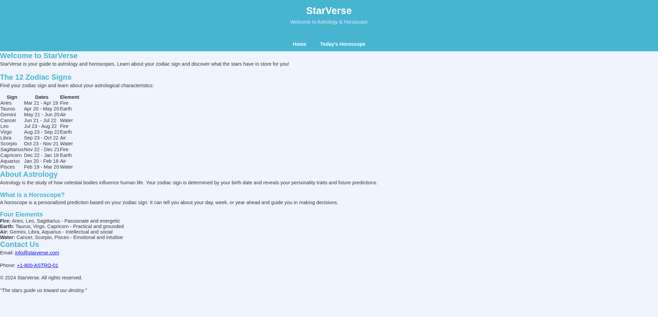

Ex. 1 | Design A Website Using HTML5
15

2.horoscope page screenshot:

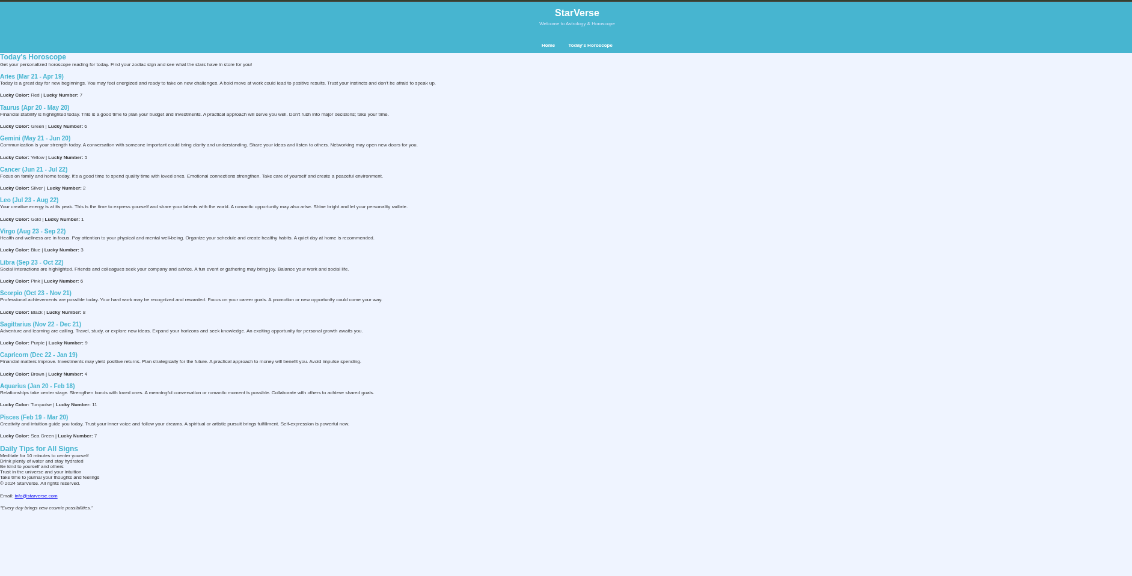

Result:

Thus, the HTML5 website StarVerse was successfully designed and developed using HTML5 semantic elements, tables, lists, hyperlinks, and CSS styling. The website executed successfully and the output was verified in a web browser.

Ex. 1 | Design A Website Using HTML5
15

Ex. 1 | Design A Website Using HTML5
2

